User and Site Set-up User Guide

Table of Contents

User ids and site names 3
Important note about site access and ownership 3
Updating selected profile information for the user currently logged in 6
Adding a site name record on the ASI server manually 7
User set-up 8
Updating user profiles 16

User ids and site names
When creating the name of a user or site you should avoid using the following characters:
- &
- , (comma)
- . (period)
For ease of use, when creating a user name you might also want to avoid using upper case letters, or a mix of upper and lower case letters in user id’s.

Important note about site access and ownership
If ASI client installation at a site precedes creation of a user account and site on the ASI server, the site record for that sub-net will be created automatically and added to the site access list for users with administrative rights (in this document we call them also master users).
This means that you can skip all the steps below that describe how to set up a site record, and how to give site access to a user with administrative rights.
Please also note that setting up a user for a specific sub-net is optional because you will be able to access a site’s event logs, asset information, and site configuration and ASI client update modules logging onto the ASI server as a user with administrative rights.
An administrative user can also change site ownership. To do this, perform the following steps:
- Log onto your ASI server’s Admin facility as a user with administrative rights (e.g. the master user). Open a browser window and type:
https://asiservername/main/acct/admin.php
Substitute asiservername with the URL of the ASI server your sites log to. Include the port for secure HTTP if you do not use the standard HTTPS port 443.
Please note that you can access the Admin page by clicking on the admin link to the right of the tools: label at the top right-hand corner of any of the ASI server pages.
- Enter your user id and password. After successfully logging on, the Admin page will be displayed (See figure below).
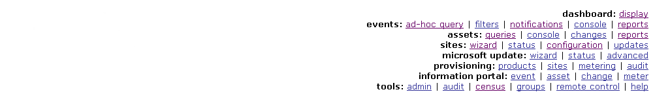
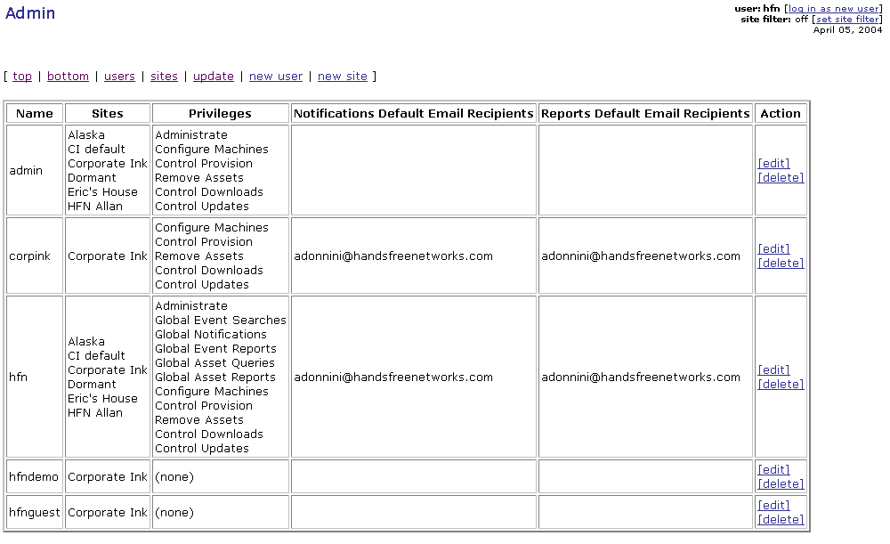
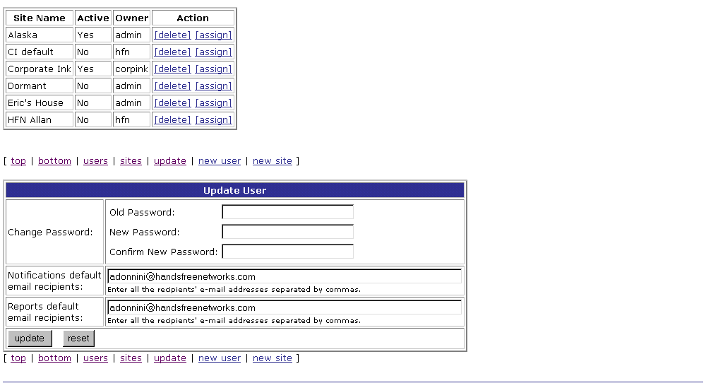

- Click on the sites navigation link found at the top of the Admin page just under the title, at the beginning and end of each section of the page, and at the bottom of the page. The Sites section will be displayed (See figure below).
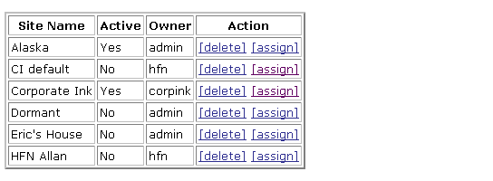
- Click on the [assign] link to the right of the entry for the site whose ownership you want to change. The Set Site Owner page will be displayed (See figure below).
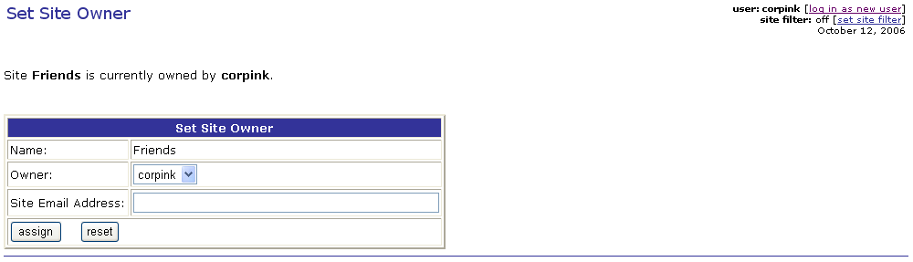
- Select the user that should be the new owner of the site from the pull-down list to the right of the Owner label in the Set Site Owner table.
- If you wish to enter a default site e-mail address for the site, enter it in the Site Email Address box. A site e-mail address entry is required in order to use the Use site e-mail address as sender address option when adding, copying, or modifying a notification.
- Click on the 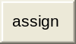 button. The Assign Site page will be displayed (See figure below).

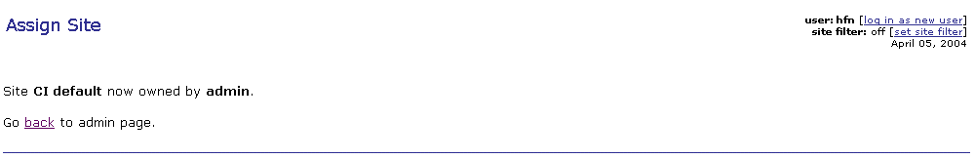

Updating selected profile information for the user currently logged in
When you need to change the list of notifications and reports default recipients, or change the password of the user id you used to log onto the ASI server, go to the Admin page by clicking on the admin link next to the tools: label at the top right-hand corner of any ASI server page.
Once on the Admin page, clicking on the update link located at the top of the page right under the page header, will take you to the Update User section of the Admin page shown below.
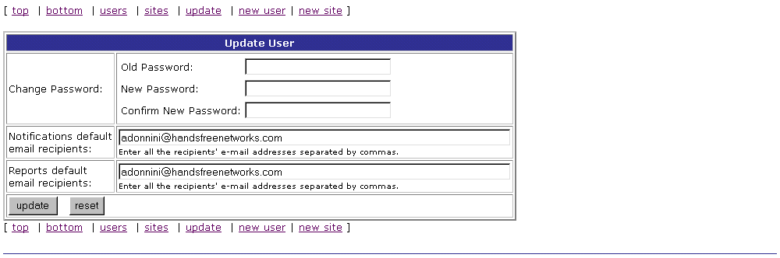
After you make the desired changes, clicking on the  button will take you to the Updating User page (See figure below).
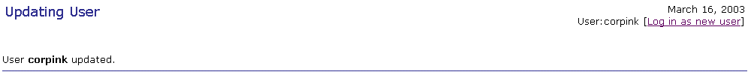
When you change a user’s password, and you are logged in as that user, the ASI server administration software requires you to log in again with the new password as indicated by the page displayed (see below) after a password change has occurred.
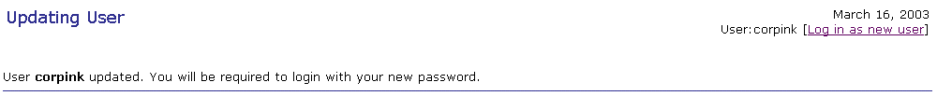

Adding a site name record on the ASI server manually
Normally, you should not have to create a site record for a new site on your ASI server. Whenever a log for an ASI client at a newly installed site reaches the ASI server, the site record and all ASI databases for that site are automatically generated.
However, there may be situations when you might have to create the record for a new site on your ASI server manually. If there is no site record on the ASI server (not to be confused with the site record defined on the ASI installation server before installation of the ASI client at a site) for one or more of the sites you want to give a new or existing user access to, you will need to create the site record for those sites. Clicking on the new site link at the top of the Admin page right under the ASI server page logo takes you to the Create Site page (See figure below).
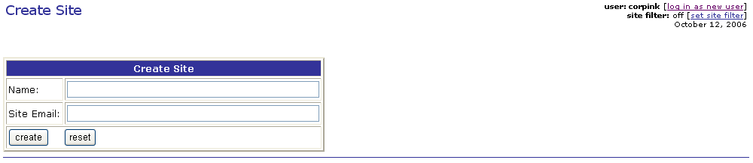
Enter the name of the site making sure that it is exactly the same as the name of the site entered in the site’s site record on the ASI installation server.
If you wish to enter a default site e-mail address for the site, enter it in the Site Email box. A site e-mail address entry is required in order to use the Use site e-mail address as sender address option when adding, copying, or modifying a notification.
Click on the  button. The Creating Site page will be displayed (See figure below).
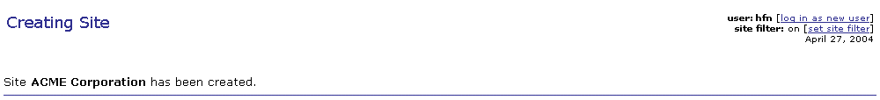

User set-up
To set up a user, perform the following steps:
- Log onto your ASI server’s Admin facility as a user with administrative rights (e.g. the master user). Open a browser window and type:
https://asiservername/main/acct/admin.php
Substitute asiservername with the URL of the ASI server your sites log to. Include the port for secure HTTP if you do not use the standard HTTPS port 443.
Please note that you can access the Admin page by clicking on the admin link to the right of the tools: label at the top right-hand corner of any of the ASI server pages.
- Enter your user id and password. After successfully logging on, the Admin page will be displayed (See figure below).

Clicking on the new user link at the top of the Admin page right under the ASI server page logo, will take you to the Create User page shown below.
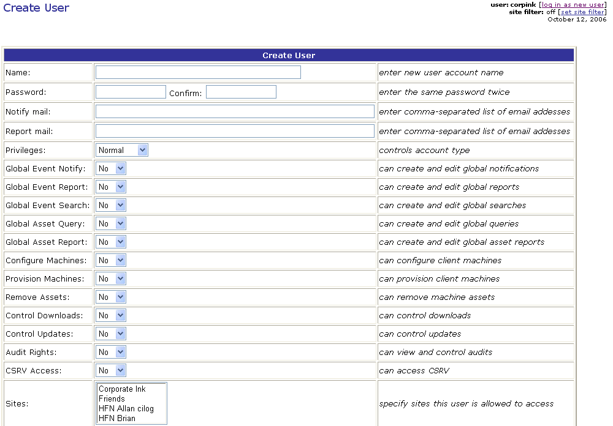
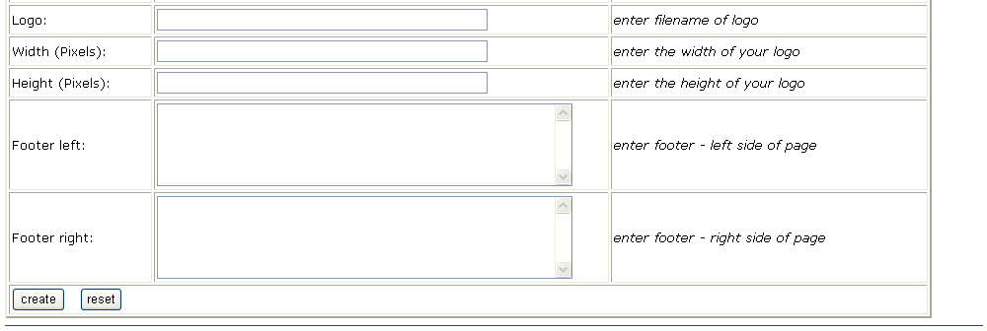
- Enter the information for the new user as follows:
- Name:
This is the user id for logging into the ASI server to view the event logs generated by the site(s) you will give this user access to, and access all the ASI facilities including event management, asset management, site management, provisioning and metering, and the census module.
- Password: and Confirm:
In these two fields you enter the password assigned to the new user. You can use any combination of letters and numbers. We recommend that a password be at least six characters long.
- Notify mail: (optional)
In this field, enter the e-mail address(es) of the recipient(s) of notifications sent via e-mail. Multiple addresses should be separated by commas. For example: groucho@marxbrothers.com,chico@marxbrothers.com
- Report mail: (optional)
In this field, enter the e-mail address(es) of the recipient(s) of reports produced for the site. Multiple addresses should be separated by commas without spaces. For example: groucho@marxbrothers.com,chico@marxbrothers.com
- Privileges – You can choose to give a new user one of three different privilege levels:
- Normal – Normal users cannot add, edit, or remove users or sites. However, they can add, edit, and remove global items (event filters, notifications, event reports, and asset queries and reports), and manage sites and ASI client updates.
- Restricted – Users with restricted access can only access the ASI information portal where they can only view reports and modify the notes associated with any report.
- Admin – Assigns administrative privileges to the user for the new site. Typically, a user for a new site should not be granted administrative privileges as these give a user the capability to add, edit, and remove both users and sites from the ASI server.
- Global Notify:
- Global Report:
- Global Search:
- Global Asset Query:
- Global Asset Report:
Assign the user for the new site the capability to create or modify global filters (searches), notifications and reports in the event log management facility, and global queries and reports in the asset management facility. Most users should not be granted these capabilities.
A user with global creation and editing rights could add or modify global filters (searches), notifications and reports in the event log management facility, and global queries and reports in the asset management facility used by multiple users on many different sites.
Please note that the ASI server has built-in safeguards that prevent even users with global creation and editing rights from deleting global filters used by reports and notifications, and global asset queries used to produce asset reports, and filters, notifications and reports, and asset queries and reports that they did not create, or that are used by other users.
- Configure Machines:
- Provision Machines:
- Remove Assets:
- Control Downloads:
- Control Updates:
Enabling the above options, gives a user access to modules in the ASI site management facility. Only users responsible for managing a site should be given these capabilities.
Selecting Yes for the Configure Machines option lets a user configure Scrips at the site(s) to which he/she has access using the ASI site management configuration module on the ASI server.
Selecting Yes for the Provision Machines option lets a user provision, enable and disable, and meter applications on one, some, or all systems at the site(s) to which he/she has access using the ASI provisioning and metering facility on the ASI server.
Enabling the Remove Assets capability will let a user delete system records from the asset database for all the sites he/she has access to.
Selecting yes for the Control Downloads and Control Updates options let’s a user manage the ASI client and Scrip update process controlling and assigning update files to the sites he/she has access to.
- Sites:
Here select the name of the site(s) whose event log and asset information you want to give the new user access to. If you want to give the user you are setting up access to more than one site, press the ctrl key while clicking with the mouse on the names of the desired sites.
Please note that if you are setting up a user in order to be able to produce event and asset reports, and notifications, and run event and asset queries covering a single site, you should make sure that you select only the site whose information you are interested in.
- Logo:
If you want to customize the ASI server pages, and event and asset report output for each user defined on the ASI server, you should enter user specific information the the fields starting with the Logo field.
In the Logo field enter the name of the file you uploaded to the https://asiservername/main/pub/patches directory following the instructions in the HFN asi server file upload instructions <company name>.doc document where in place of <company name> you should have the name of your company or the your ASI server user id.
- Width (Pixels):
Here, enter the width of the logo file whose name you entered in the Logo field in pixels. If you enter incorrect width information, the image will be stretched horizontally or compressed accordingly. If you do not enter a value for the Width (Pixels) parameter, it will assume the value entered for the ASI server logo entered in field logo_x in the ASI server configuration page at
https://asiservername/main/acct/server.php
- Height (Pixels):
Here, enter the height of the logo file whose name you entered in the Logo field in pixels. If you enter incorrect height information, the image will be stretched vertically or compressed accordingly. If you do not enter a value for the Height (Pixels) parameter, it will assume the value entered for the ASI server logo entered in field logo_y in the ASI server configuration page at
https://asiservername/main/acct/server.php
- Footer left:
In the Footer left parameter, you enter any information you wish to be listed at the left-most edge of each ASI server page when the user you are defining logs onto the ASI server. If you want the information to be listed in multiple lines, please end each line with a <br> character sequence as ASI server pages are coded in HTML
- Footer right:
In the Footer right parameter, you enter any information you wish to be listed at the right-most edge of each ASI server page when the user you are defining logs onto the ASI server. If you want the information to be listed in multiple lines, please end each line with a <br> character sequence as ASI server pages are coded in HTML
- After you finish entering the desired values for the above parameters on the Create User page you will have successfully created a new user. Click on the button. The Creating User page will be displayed (See figure below).

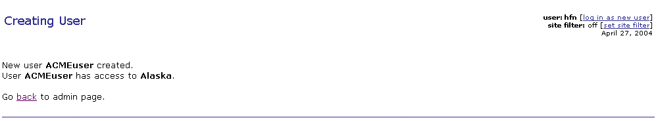

If you were not able to select a site because the site name record on the ASI server had not been created (either manually or automatically when ASI client at the site started logging events and actions onto the ASI server), you should proceed to step 6) below.
- If you created the new site by using the new site link as described above, you will need to give the new user access to the site performing the following steps, otherwise the user set-up process is completed:
- Clicking on the users link at the top of the Admin page right under the page title, will take you to the Users area on the Admin page.
- Clicking on the [edit] link in the rightmost column entry corresponding to the name of the new user (the user just created), will take you to the Edit User page for the new user (See figure below).

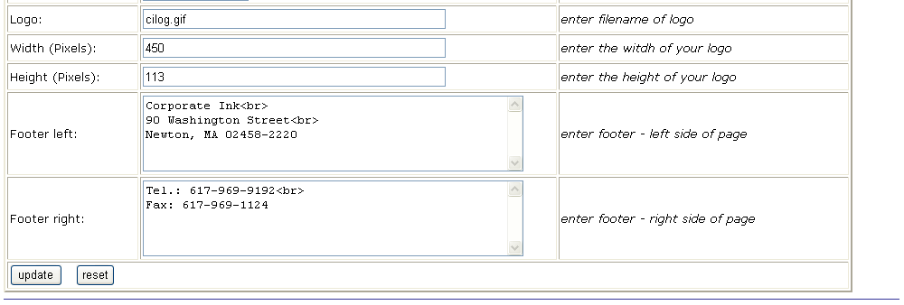
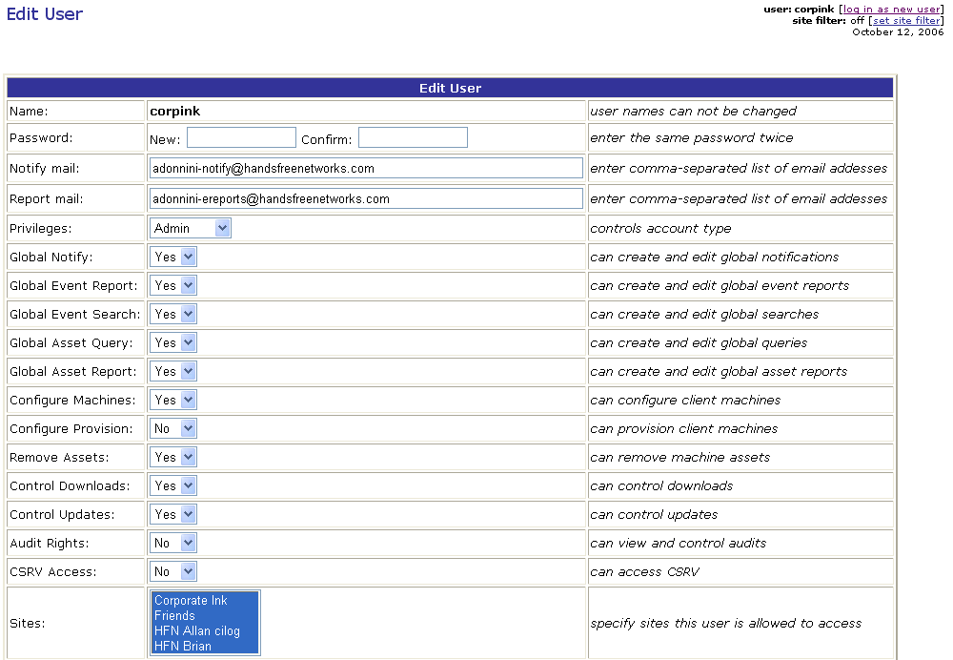
- Scroll down the list next to the Sites label until you locate the entry for the new site, and select it by clicking on it. If you want to give the new user access to more than one site, press the ctrl key while clicking with the mouse on the names of the new site(s).
- Click on the button to complete the process. The Admin Updating User page will be displayed (See figure below).

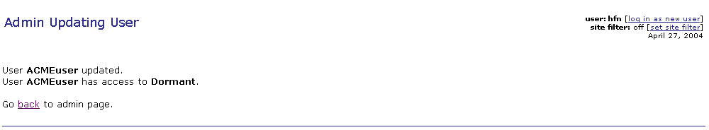

Updating user profiles
In order to change a user’s profile, perform the following steps:
- Log onto your ASI server’s Admin facility as a user with administrative rights (e.g. the master user). Open a browser window and type:
https://asiservername/main/acct/admin.php
Substitute asiservername with the URL of the ASI server your sites log to. Include the port for secure HTTP if you do not use the standard HTTPS port 443.
Please note that you can access the Admin page by clicking on the admin link to the right of the tools: label at the top right-hand corner of any of the ASI server pages.
- Enter your user id and password. After successfully logging on, the Admin page will be displayed (See figure below).

- Clicking on the users link at the top of the Admin page right under the page title, will take you to the Users area on the Admin page.
- Clicking on the [edit] link in the rightmost column entry corresponding to the name of the user whose profile you want to modify, will take you to the Edit User page for that user (See figure below).
Change the user profile information, including rights and capabilities, as desired. Please refer to the User and site set-up section of this document for detailed information on each user profile parameter.
Please remember that If you want to change the sites you want the user whose profile you are editing to access, press the ctrl key as you click on the site(s) that you want to select or-de-select, otherwise you will lose the site selection settings.
- Click on the button to complete the user profile editing process. The Admin Updating User page will be displayed (See figure below).

